Medex Objectives Fall 2002
MEDEX Northwest Physician Assistant Objectives Home: http://faculty.washington.edu/alexbert/MEDEX/
Last updated 7 Dec 2003
HEENT Physical Exam Objectives

1. Be able to describe the components of the HEENT Exam, and when and why portions are done.
Paul, HEENT Branching Exam
Pushes on tragus tenderness
Mastoid process tenderness, edema, redness
Inspects with otoscope:
Following vital signs:
Head: inspects:
Face asymmetry, involuntary movements, acne, hirsutism
Hair alopecia, texture, nits
Scalp redness, scaling

Palpates:
Skull (including temporal artery) size, contour, lumps, deformities, tenderness
Temporomandibular joint pain, decreased ROM

Eyes: visual acuity decreased acuity
Visual fields field deficits
Inspects:
Eyebrows hair loss, scaling
Eyelids & lacrimal apparatus redness, swelling, lesions
Lacrimal apparatus weakness, tearing
Conjunctiva & sclera icterus, paleness, inflammation
Cornea (anterior chamber) opacities
Lens
Inspects pupils & check alignment size, shape, equality
Tests papillary reactions direct & consensual response
Tests accommodation Argyll Robertson and tonic pupils
Tests convergence asymmetry, nystagmus
Extraocular movements asymmetry, nystagmus
Fundoscopy red reflex, opacities, disc, vessels, etc

Ears:
Inspects:
Auricle (anterior & posterior) deformities, lumps, lesions, position
Pre/posterior auricular area surgeries, sinus tracts
Palpation:
Pulls on pinna tenderness

External canal cerumen, discharge, foreign bodies, swelling
Tympanic membranes color, landmarks, bulging, retraction, perforation, scarring
Insufflation TM mobility
Tests auditory acuity decreased hearing
Weber test lateralizationRinne test BC vs AC
Nose & sinuses
Inspects
External nares asymmetry, deformity
Internal nares with otoscope swelling, turbinates, septal deviation, perforation, discharge, blood, crusting, ulcers, polyps
Palpates sinuses – frontal tenderness
Palpates sinuses – maxillary tenderness

Mouth and Pharynx (throat)
Inspection
Lips color, moisture, lumps, ulcers, cracking
Buccal mucosa color, lesions
Teeth & gums inflammation, swelling, bleeding, retraction, discoloration
Loose, missing or carious teeth
Tongue (sides, underside, floor) asymmetry, lesions, salivary ducts
Palate lumps, lesions
Tonsils presence, size, color, pus, symmetry
Pharynx & uvula asymmetry, inflammation, swelling, tonsillar enlargement
Exudates, deviation
Tests voice quality hoarseness
VB Syllabus
• General appearance- observe for habitus, level of comfort/distress,
• Vital signs- check for fever
• Head/Scalp/Skull- asymmetry, involuntary movement, acne, hirutism, alopecia, texture, nits, redness, scaling
• Eyes- visual acuity, field defects
Eyebrows hair loss, scaling
Eyelids/ lacrimal apparatus redness, swelling, lesions
Lacrimal apparatus weakness, tearing
Conjuctiva Icterus, paleness
Sclera inflammation
Cornea / Lens Opacities
Pupils reaction/size/shape/equality/direct and consentual reaction
Convergence
Extraocular movement assymentry/nystagmus
Funduscopy red reflex/ opacities
• Ears-deformities, tenderness (pinna, tragus, mastoid process), cerumen, discharge, color,
TM- mobility, landmarks, light reflex, perforations
• Nose- swelling, symmetry, deformities, turbinates, septal deviation, discharge, blood, ulcers, polyps, tenderness.
• Throat- (mouth, lips, pharynx)- color, ulcers, inflammation, enlarged tonsils, exudates, node enlargement, tracheal deviation
Review Anatomy of head and neck. Identify common structures in region assessed on PE
ANN
If a patient has a chief complaint of any one of the head, eyes, ears, nose, and throat (HEENT) symptoms, you must generally ask all of the HEENT ROS questions. Because the ears, nose, and throat are anatomically connected, infection or obstruction in one structure can lead to illness or symptoms in the others. With certain complaints, you may wish to include respiratory-related questions. Ballweg, pg. 173-174

2. Review the anatomy of the head and neck (Bates, chapter 7). Be able to identify common structures in this region which are routinely assessed on the physical exam including:
external eye
external ear
tympanic membrane
frontal and maxillary sinuses
mouth and pharynx
lymph nodes of the head and neck
lymphatic drainage of the head and neck
Zen Seeker
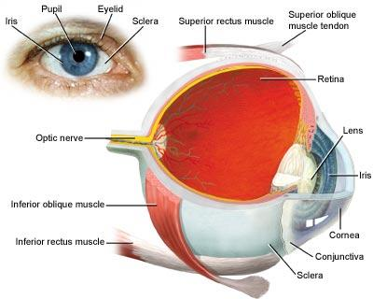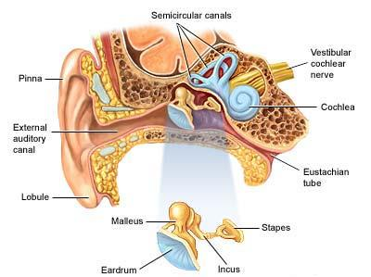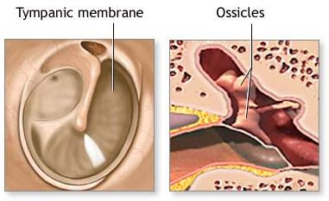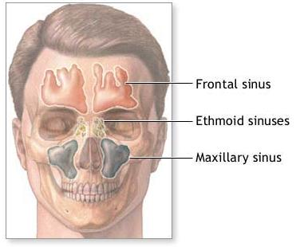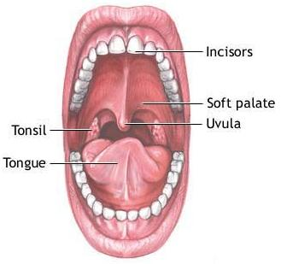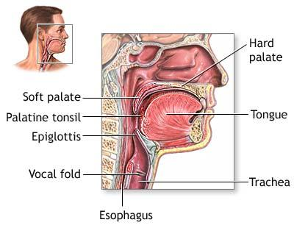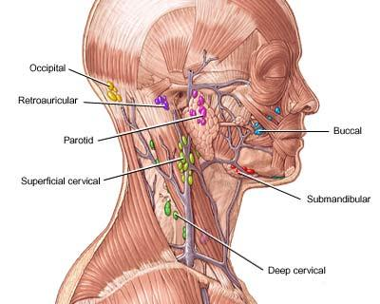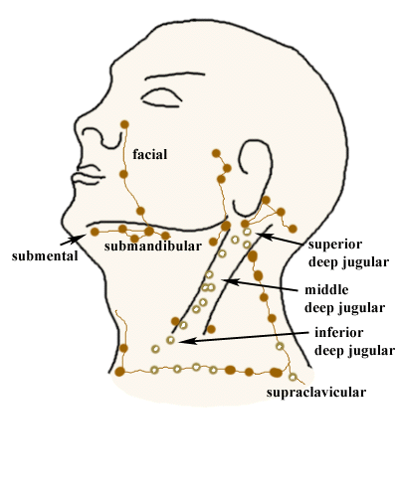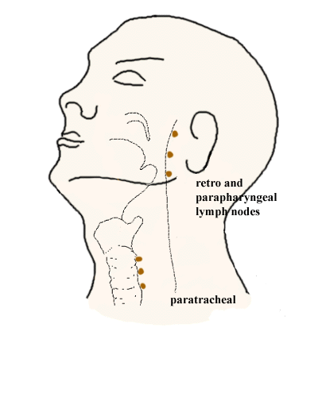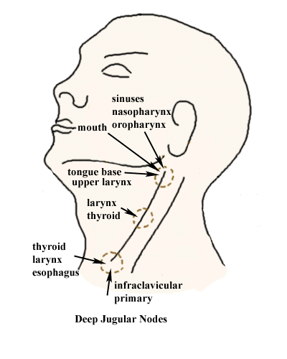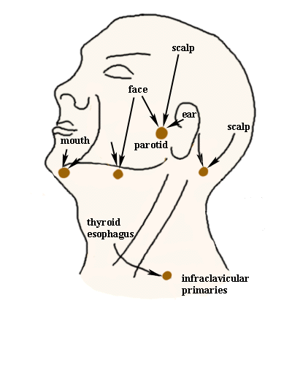
VB. Bates 7th ed
• External eye-(pg 164-165)- canthus(medial/lateral), conjuctiva, iris, pupil, eyelids, limbus, puntum
• External ear-(pg 171)- pinna, tragus, preauricular/ postauricular area, mastoid process
• TM-(171)- pars flacida, pars tensa, malleous, light reflex
• Mouth/ pharynx- (200-201)- lips, oral mucosa, teeth, gums, palate, tounge, posterior pillars, uvula, tonsils.
• Lymphatic nodes/ head/ neck-(203)- Preauricular, posterior auricular, occipital, tonsilar, submandibular, submental, anterior cervical, posterior cervical, supraclavicular.
• Lymphatic drainage of head/neck-(181)- whenever malignant or inflammatory lesion is observed, look for involvement of regional lymph node that drains it.
Whenever a node is enlarged or tender, look for source such as infection on area that drains it.
ANN
Ext. eye – illustration, pg. 195 Swartz;
Ext. ear - illustration, pg. 258 Swartz
Tympanic membrane – illustration, pg. 259 Swartz
Frontal and maxillary sinuses - pg. 263 Swartz These air-filled cavities within the skull are lined with mucous membrane and drain into the nasal cavities. Only the frontal and maxillary sinuses are readily accessible to clinical exam. Bates 174
Mouth - (lips, gingiva, teeth, tongue ,palate, tonsils) and pharynx (includes uvula) illustration, pg. 286 Swartz
Lymph nodes of head and neck – It is estimated that the neck contains more than 75 lymph nodes on each side. The chains of nodes are named for their location, starting posteriorly they are: occipital, posterior auricular, posterior cervical, superficial and deep cervical, tonsillar, submaxillary, submental, anterior auricular and supraclavicular. Knowledge of the lymphatic drainage is important, because the presence of an enlarged lymph node may signal disease in the area draining into it. Illustration, p. 182 Swartz
Lymph drainage of head and neck: tonsillar, submandibular, and submental nodes drain portions of the mouth and throat as well as face. text and illustration pg. 181 Bates; in Swartz, see illustration pg. 182

3. Describe common changes with age that occur in the head and neck.
Anonymous
Neck- Lymphoid tissue such as tonsils becomes smaller & eventually inconspicuous or invisible. Submandibular glands become easier to feel in older people.
Eyes, ears and mouth- visual acuity diminishes gradually until about age 70 and then more rapidly. Near vision begins to blur noticeable for virtually everyone. The lens gradually loses its elasticity and the eye grows progressively less able to focus on nearby objects. Presbyopia (loss of accommodative power) becomes noticeable in one’s 40s. In some elderly people the fat that surrounds and cushions the eye within the bony orbit atrophies, allowing the eyeball to recede somewhat in the orbit. Combinations of a weakened levator palpebrae, relaxation of the skin, and increased weight of the upper eyelid may cause a senile ptosis (drooping). The lower lid may fall outward away from the eyeball or turn inward onto it, resulting in ectropion and entropion, respectively p.213. Eyes of the elderly also produce fewer lacrimal secretions. Corneal arcus (arcus senilis-p. 213) is common in elderly people. Pupils become smaller and slightly irregular with aging. Lenses thicken and yellow and frequently look gray. Cataracts are common and some elderly develop narrow-angle glaucoma p. 188. Fundi lose their youthful shine & light reflections. The arteries narrow become paler, straighter and less brilliant p. 226. Drusen (colloid bodies) may be seen p. 223. Degenerative changes include annoying specks or webs in the field of vision, macular degeneration, glaucoma, retinal hemorrhages or possibly retinal detachment.
Ears- Acuity of hearing diminishes esp. the high-pitched sounds. Presbycusis develops about the age of 50.
Mouth- Salivary secretions and sense of taste decrease. Teeth wear down and periodontal disease causes tooth loss. Overclosure of the mouth leads to maceration of the skin at the corners-angular cheilitis p. 234.
Paul, Swartz pg 183
Neck mass: a lump in the neck of a patient younger than 20 years of age may be an enlarged tonsillar lymph node or congenital mass. From 20-40 years of age, thyroid disease is most common. Patients older than 40, a neck mass must be considered malignant until proved otherwise.
VB. Bates 7th ed. Pg 182
Adolecence- voice deepens and thyroid cartlidge enlarges in males, facial hair appears, lengthening of eyeballs, comedores, blackheads, acne.

Aging- tonsils become smaller, decrease in visual/hearing acuity, lenses thicken and become yellow, cataracts formation, decrease in salivary secretions and taste, teeth wear down and may be lost.
ANN Bates, pg.181-183
In adolescence: In boys, voice deepens, growth of facial hair; subtle facial contour changes in boys and girls; lengthening of anteroposterior diameter of eyeballs may cause/accentuate near –sightedness; blackheads and pustules of acne on face;lymph nodes remain palpable.
Upon aging: Tonsils become smaller; cervical nodes less palpable but submandible glands easier to feel. The eyes, ears, and mouth bear the brunt of old age:
EYES -After age 50, visual acuity gradually diminishes and more rapidly after 70. Fat tissue around the eye (a cushion in bony orbit) atrophies, eyelids droop (ptosis); dry eyes due to decreased lacrimal secretions; pupils become smaller, corneal arcus (arcus senilis) common but not clinically significant; lenses thicken; cataracts develop. As lenses continue to grow, may push iris forward causing narrow-angle glaucoma. Ophthalmoscopic exam reveals: fundi lose shine and light reflections; arteries look narrowed, paler, straighter, and less brilliant; may see vitreous floaters and serious conditions such as macular degeneration, glaucoma, retinal hemorrhages, or possibly retinal detachment.
EARS – Hearing, like vision diminishes (Presbycusis=hearing loss upon aging). Early loss includes high pitched sounds, followed by loss to middle and lower ranges. Words sound distorted and are diffiult to understand especially in noisy environments.
TASTE - diminished salivary secretions and sense of taste are usually attributed to aging but medications and disease states are probably more likely the cause. Teeth wear down, tooth loss due to periodontal disease.

4. Identify common abnormalities which may be found on examination of:
the hair
the scalp
the skull
Anonymous
Hair- Hair loss (alopecia), nits (eggs of lice) & hair that is fine in hyperthyroidism.
Scalp- Scaliness, lumps or lesions. Redness and scaling in seborrheic dermatitis, psoriasis; pilar cysts (wens).
Skull- Deformities, lumps or tenderness. Enlarged skull in hydrocephalus, Paget’s disease of bone. Tenderness after trauma.
Paul, Swartz pg 130
Hair and scalp: for any lesions, psoriasis. Is alopecia or hirsutism present? Pay attention to the pattern of distribution and texture of hair over the body. Hypothyroidism: hair becomes sparse and coarse. Hyperthroidism: hair becomes very fine in texture. Loss of hair occurs in many conditions: anemia, heavy metal poisoning, hypopituitarism, and some nutritional disease states (pellagra). Increased hair patterns are seen in Cushing”s disease; Stein-Leventhal syndrome; and several neoplastic conditions (tumors of the adrenals and gonads)
Skull: palpated for tenderness or masses. Swartz pg 185
VB. Bates 7th ed. Pg 184
Hair- alopecia, fine hair (hyperthyroidism), course hair (hypothyroidism), nits
Scalp- seborrheic dermatitis, psoriasis, pilar cysts
Skull- hydrocephalitis, Paget’s disease, tenderness second to trauma.
ANN Pg. 184 Bates
The hair - fine hair in hyperthyroidism; coarse hair in hypothyroidism. Nits are the eggs of lice.
The scalp – redness and scaling in seborrheic dermatitis, psoriasis; pilar cysts (wens)
The skull – enlarged skull in hydrocephalus, Paget’s disease of bone; tenderness after trauma.

5. Identify the purpose of testing:
visual acuity
visual fields by confrontation
Zen Seeker
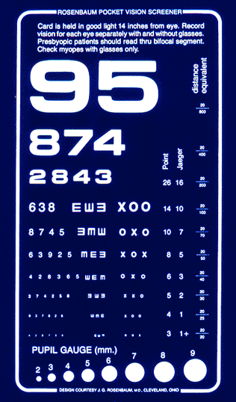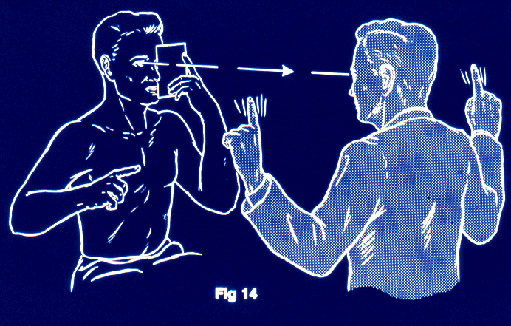
Anonymous
Visual acuity- To check for the need for vision correction (reading glasses, contacts, etc.). Screen for myopia (far vision), presbyopia (near vision) or blindness.
Visual Fields by Confrontation- To screen for field defects such as; homonymous hemianopsia (blindness on one half of field in both eyes), bitemporal hemianopsia (blindness in half of field nearest the temples bilaterally) & quadrantic defect (blindness in ¼ field bilaterally). Explaining these are difficult, for a better understanding please see pictures on page 185 of Bates.
Paul, Swartz pg 206 – 207
Visual Acuity: tests vision
Visual fields by confrontation: may provide the first objective evidence that the patient has a lesion involving the visual pathway.
VB. Bates 7th ed. Pg 184-185
Visual acuity- decreased acuity, and helps to identify the need for reading glasses or bifocals in those over 45 years old. Also looking for myopia (impaired far vision), presbyopia ( impaired near vision).
Visual fields with confrontation- to check for visual field defects; bitemporal, quadrant defects.
ANN Bates pg. 185-186
Visual acuity – done to test the acuity of central vision using an eye chart. Visual acuity is expressed as two numbers (ie. 20/30) in which the first indicates the distance of patient from chart, and the second, the distance at which a normal eye can read the line. (at 20 feet this person can read print that a person with normal vision could read at 30 feet).
Visual fields by confrontation – screening starts in temporal fields because most defects involve these areas. During this maneuver, if patient sees both sets of the examiner’s fingers at the same time, fields are usually normal. However, if a deficit is found, try to establish its boundaries. This involves moving your fingers from the defective area toward the area of better vision, noting where the patient responds and repeated at several levels. A temporal defect in the visual field of one eye suggests a nasal defect in the other eye. Test this hypothesis by repeating test in other eye.

6. Define exophthalmos and name two possible causes.
Zen Seeker
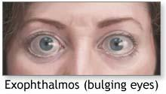
Anonymous Bates; pg. 213
This is an abnormal protrusion of the eye, 2 possible causes are Graves disease or a tumor of the orbit.
source:
Brent K Taber’s medical dictionary.
Exophthalmos is the abnormal protrusion of the eyeball. It may be due to an orbital tumor or cellulites, Leukemia, or aneurysm.
Tanner
Exophthalmos is the bulging of one or both eyes. A large portion of the eye is exposed and the eyelids are forced open because of the bulging.
Exophthalmos occurs when the soft tissue lining the eye socket swells. This can happen with a type of thyroid disease called Graves’s disease, which is the most common cause of exophthalmos
A tumor or abnormal blood vessels behind the eye could also push the eye forward.
A bacterial infection in the eye socket (orbit), called orbital cellulites, may also cause the eye to bulge. If not treated quickly and properly, this infection can spread from the eye socket to the brain. It may cause permanent loss of sight and can be life threatening.

7. Identify common abnormalities which may be found on examination of:
the eyebrows
the eyelids
the lacrimal apparatus
Anonymous
Eyebrow:
Seborrheic dermatitis
Lateral sparseness due to hypothyroidism.

Eyelid:
Blephantis, an inflammation of the eyelids along the lid margins.
Retracted lids. Retracted lids and lid lag are often due to hypothyroidism.

Lacrimal apparatus:
Obstruction of the nasolacrimal duct.
Dacryocystitis; is the inflammation of the lacrimal sac.
source: Bates; pgs 213 & 214
Brent K Swartz 212-215 & Bates 186
Common abnormalities of:
Eyebrows- inspect eyebrows noting their quantity and distribution, in addition to any scaliness. Lateral sparseness can be seen in hypothyroidism and scaliness can be present with seborrheic dermatitis.
Eyelids- upon inspection, note evidence of drooping, infection, erythema, swelling, crusting, masses, position, or other abnormalities.
Specific abnormalities:
Blepharoptosis or ptosisis is drooping of the eyelid.
Entropion is a turning inwards of the lid margin such that the eyelashes abrade the cornea and eyeball.
Ectropian is turning outwards of the eyelid margin. Both ectropian and entropian may be seen as changes associated with aging.
Chalazion is a granulomatous reaction to thickened secretions of the sebaceous meibomian gland in the lid. It appears as a localized mass on the eyelid around the orifice of the gland.
In herpes zoster ophthalmicus, there are rows of vesicles, ulcers, and crusted scabs that are scattered along the branches of the ophthalmic division of the trigeminal facial nerve. Can be excruciatingly painful.
Orbital pigmentation or raccoon eyes is an important sign of an orbital fractures.
Xanthelasma are flat or slightly raised yellowish tumors found on the upper and lower lids as a result of lipid deposition in the periorbital skin.
A stye is a localized abscess in an eyelash follicle caused by a staph infection. It is a painful red infection that looks like a pimple pointing on the lid margin.
Blepharitis is chronic inflammation of the eyelid margins. The most common for is associated with small white scales around the lid margin and eyelashes which stick together and fall out. Frequently associated with seborrheic dermatitis.
Swartz 226-There is little to be seen of the lacrimal apparatus, with the exception of the punctum.
Abnormalities:
Epiphora or tearing may be due to obstruction to flow through the punctum.
Lacrimal gland enlargement may be noted, possibly due to sarcoidosis and hyperthyroidism.
Dacryocystitis describes inflammation of the lower lacrimal passages. Causes include congenital anomalies, infection, and stenosis of the lacrimal duct.
Tanner
- Eyebrows- Hair loss, scaling
- Eyelids & lacrimal apparatus- Redness, swelling, lesions, weakness, tearing

8. Identify the potential significance of
yellow sclera
pale palpebral conjunctiva
Anonymous. pg 187; Bates
Yellow Sclera.-Indicates Jaundice or liver disfunction

Pale palpebral conjunctiva.- This would indicate an anemic person or someone with an iron deficiency in their blood. Almost everything else in the conjunctiva have an increased redness or inflammation. The anemia causes it to be pale,
Anonymous Bates; pg. 187
Identify the potential significance of yellow sclera:
Jaundice

Identify the potential significance of pale palpebral cunjuctiva:
Anemia
Brent K Swartz 218. Yellow sclera is usually present with jaundice, which is the yellowish discoloration of the sclera, skin, and mucous membranes, caused by retention of bilirubin. This discoloration may be indicative of biliary or hepatic problems.
Pale palpebral conjuctiva- Source not found! Possibly due to cardiac and/or respiratory deficiencies resulting in poor perfusion of the tissue???
Tanner Bates; pg. 187
- Jaundice, or icterus, is a yellowish discoloration of the sclera, skin, and mucous membranes and is caused by retention of bilirubin or its products of metabolism.
- Anemia

9. Define or describe the following terms or tests related to eyes:
anisocoria
miosis
mydriasis
direct and consensual reaction
near reaction
tests for weakness or imbalance of the extraocular muscles
nystagmus
lid lag
Zen Seeker
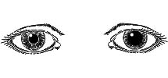
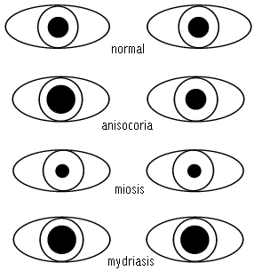
Anonymous
Anisocoria- unequal pupils. Bates, p217
Miosis- refers to the constriction of the pupils. Bates, p. 188
Mydriasis- refers to the dilation of the pupils. Bates, p.188
Direct and consensual retraction- pupillary constriction in the same eye and the opposite eye, respectively. Bates, p. 188
Near retraction- pupillary constriction on a near object when alternating focus between a near and distant focal point. Bates, p. 189
Tests for weakness or imbalance of the exrtaocular muscles- The cover-uncover test can detect an imbalance in ocular muscle tone known as nonparalytic strabismus. A direction of gaze test can show paralytic strabismus which is caused by a weakness/paralysis of extraocular muscles. Bates, p.218
Nystagmus- a rhythmic oscillation of the eyes, analogous to a tremor in other parts of the body. An extraocular movement. Bates, p. 606
Lid lag- an extraocular movement as the eyes move from above downward. Bates, p. 189
Brent K Swartz pg #’s listed individually
Define the following:
Anisocoria- unequal pupil size. p220
Miosis- papillary constriction. p220
Mydriasis- enlarged or dilated pupils. p220
Direct reaction- pupillary constriction in the same eye. p211
Consensual reaction- pupillary constriction of the opposite eye. p211
Near reaction- have pt first focus on some distant target and then place an object, such as a pencil, about 5 inches from the pt’s nose. As the pt adjusts their focus, the eyes should converge and pupils should constrict. p211
Testing for weakness or imbalance of the extraocular muscles is evaluated by the “H” test. This test evaluates the 6 positions of gaze. p210
Nystagmus is a fine rhythmic oscillation of the eyes. Evaluated with the “H” test. A few beats of nystagmus on extreme lateral gaze (end-point nystagmus) are within normal limits. p210
Lid lag- eye and eyelid don’t move together. Can be seen in pts with hyperthyroidism. p210
Tanner
1. Anisocoria: Inequality in size of the pupils of the eyes. Dorlands Medical Dictionary
2. Miosis: Contraction of the pupil. . Dorlands Medical Dictionary
3. Mydriasis: Dilation of the pupil. Dorlands Medical Dictionary
4. direct and consensual reaction: reaction of the direct pupil to light and equal reaction of the opposite pupil. Swartz P 211
5. near reaction: is when the patient looks first at some distant target and then at a target placed about 5 inches away from his or her nose. When the patient focuses on the near target, the eyes should converge, and the pupils should constrict. Swartz P 211
6. Tests for weakness or imbalance of the extra ocular muscles: This is the test in which you move your finger in the H position looking for asymmetry or nystagmus. Swartz P 210
7. Nystagmus: involuntary rapid movement (horizontal, vertical, rotatory, or mixed, i.e., of two types) of the eyeball. Dorlands Medical Dictionary
8. Lid lag: during extraocular test if the Eye and eyelid do not move together. Swartz P. 210

10. Be able to describe the following parts of the normal funduscopic exam and identify them if given a diagram:
red reflex
optic disc
physiologic cup
arterioles
veins
macula
fovea
Zen Seeker
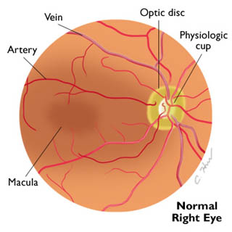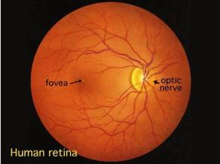
Anonymous Bates, p. 192-194
red reflex – orange/red glow seen inside pupil; “red eye” in pictures.
optic disc – yellowish orange to creamy pink oval or round shaped structure in the back of the eye; visualized by following blood vessels, as they get larger, to disc.
physiologic cup – center of the optic disc, normally yellowish-white and is usually less then ½ the horizontal diameter of the optic disc.
arterioles – smaller vessels in eye that have a bright reflex when light is on them
veins – larger vessels in eye, appear dark red, may be inconspicuous or absent
macula – lateral to the optic disc; lighter color viewed around fovea; to view, ask pt to look directly into light.
fovea – lateral to optic disc; darker color inside macula with a central light color
reflection.
Anonymous
Red Reflex = Shows an orange glow when a bright light is shined into the eye.

Optic disc = Tiny disc vessels give normal color to the disc. Disc color is yellowish orange to creamy pink. Disc vessels are tiny and Disc margins are sharp (except nasally)

Physiologic cup = Is located centrally or somewhat temporally. It may be conspicuous or absent. Its diameter from side to side is usually less than half that of the disc.

Arterioles = The normal arterial wall is transparent. Only the column of blood within it can usually be seen as light red with a bright reflex. The normal size is about 2/3 to 4/5 the diameter of the veins.

Vein = Because the arterial wall is transparent, a vein crossing beneath the artery can be seen right up to the column of blood on either side. The vein color is usually dark red, and its size is usually larger than arteries. Light reflex is usually inconspicuous or absent.

Macula = Lateral to the Optic disc is a dark pigmented opaque area called the macula luteas which surrounds the fovea centralis.

Fovea = Except in older people there usually is a tiny bright red reflection at the center of the fovea, which is in the center of the macula, shimmering light reflections are common in young people.
Brent K Swartz 227 & Bates 192
Red reflex- Red glow seen with shining light directly into pupil providing the path isn’t obstructed. Absence of this reflex suggest an opacity of the lens (Cataract) or possibly of the vitreous. Other, but less common possibilities include, detached retina or retinoblastoma in children.
Optic disc- yellowish orange to creamy pink oval or round structure. Take note of its margins, color, and cup-to-disc ratio. The disc should have sharp borders, although the nasal border may be somewhat blurred. Its long axis should run vertically.
Physiologic cup- found in the center of the optic disc. This funnel shape depression is light in color and penetrated by the retinal vessels. Cup-to-disc ratio should be checked in both eyes for symmetry .
Arterioles- The central retinal artery enter through the physiologic cup and divides into 4 main braches. Arteries are light red two-thirds to four-fifths the diameter of veins and have a prominent light reflex.
Veins- Color are dark red, larger than arteries and light reflex is inconspicuous or absent.
Macula- A yellow spot in the center of the retina lateral to the exit of the optic nerve.
Fovea- pit in the middle of the macula made up of a layer of closely packed cones. Functions as the area of most acute vision.
Tanner
1. Red Reflux: A luminous red appearance seen upon the retina in retinoscopy
2. For Optic Disc, Physiologic cup, arterioles, veins, macula, and fovea refer to P. 200 in Swartz

11. Describe or identify each of the following, and any significance:
normal blurring of the disc outline on the nasal side
normal rings and crescents
normal size vs. enlargement of the central physiologic cup
how to tell arterioles from veins
how to measure within the eye by disc diameters
absent red reflex
AV nicking
Zen Seeker
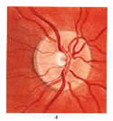 | 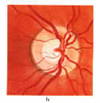 | 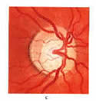 | 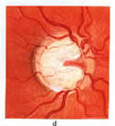
Optic Nerve Head (a. - d., left to right)
- Normal optic nerve head with small central physiologic cup, C/D ratio about 0.2
- Concentric enlargement of the central cup, C/D ratio about 0.5
- Irregular enlargement of the cup, especially inferiorly due to loss of inferior neural rim tissue
- Marked glaucoma cupping with high degree of central atrophy, C/D ratio 0.7 to 0.8
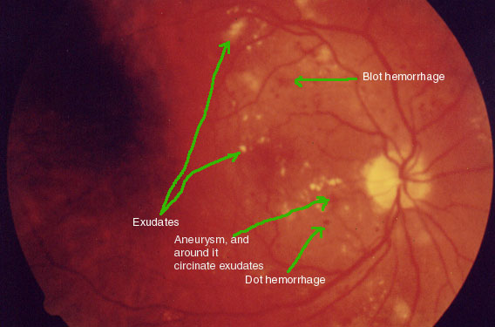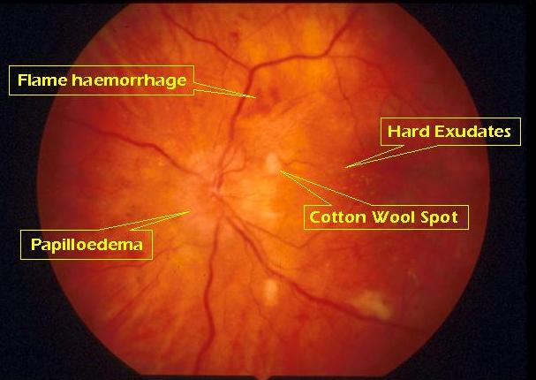
Anonymous Bates, p. 192-195
normal blurring of the disc outline on the nasal side – the disc outline should always be clear except for on the nasal side, in which blurring is normal.
normal rings and crescents – often seen around the optic disc; developmental variations in which a glimpse is caught of white sclera, black retinal pigment, or both, especially on the temporal border.
normal size vs. enlargement of the central physiologic cup – normal size is usually ½ the horizontal diameter of the disc – enlargement suggests chronic open angle glaucoma.
how to tell arteries from veins – arteries appear light red, smaller, and have a bright light reflex, while veins appear dark red, larger, and may be inconspicuous or absent.
how to measure inside the eye by disc diameters – lesions of the retina can be located in relation to the size of the optic disc and are measured as “disc diameters”.
absent red reflex – suggests an opacity of the lens (cataract) or possible opacity of the vitreous, detached retina (less common), or in children, a
retinoblastoma (of course the eye could be artificial – don’t be fooled J)
*AV nicking – localized constriction of retinal blood vessels Dorland’s
Anonymous how to tell arterioles from veins
Arterioles Veins

Color light red dark red

Size smaller (2/3 to 4/5 veins) larger

Light reflexion bright inconspicuous or absent
Anonymous
normal blurring of the disc outline on the nasal side no sig., p.193

normal rings and crescents
Normal white or pigmented (often black) rings or crescents are seen at disc edge (often temporal border), p. 219, drawing.

normal size vs. enlargement of the central physiologic cup
If present, central physiological cup is usually less than half the horizontal diameter of the disc. An enlarged cup suggests chronic open-angle glaucoma, p.220, drawings.

how to tell arterioles from veins

 | Arteries | Veins
Color | light red | dark red
Size | smaller (2/3 to 4/5 veins) | larger
Light reflexion | bright | inconspicuous or absent

how to measure within the eye by disc diameters
Lesions of the retina are measured by “disc diameters.” Describe both the size and position of the lesion(s) relative to the optic disc. Example: 1 x ½ disc diameter “cotton wool” lesion seen at 2 o’clock, approx. ½ disc diameter from disc. p. 195.

absent red reflex
Suggests an opacity of the lens (cataract) or the vitreous; less commonly, detached retina or, in children, retinoblastoma. Also, artificial eye. p.192.

AV nicking
A vein appears to stop abruptly on either side of an artery. Occurs in hypertension when the arterial walls lose their transparency. p. 221, drawing.
Michelle Swartz pg. 200
A. The optic disc is located at the nasal aspect of the posterior pole of the retina. This is the haed of the optic nerve from where the nerve fibers of the retina exit the eye. The disc margins are normally sharp with some normal blurring of the nasal portion, so this is a normal finding.
B.
C. The physiologic cup is the center of the disc, where the retinal vessels penetrate. The normal ratio of the cup tp disc ratio varies from 0.1 to 0. 5.
D. Arteries are brighter red and thinner than viens. An artery to vien ratio is 2:3 to be normal.
E. I
F.If red reflex is present it indicates that there is no serious obstruction to light between the cornea and the retina.
Sung K, Bates, p.192-3,5, 219 and Barkauskas, p.281 and Stevens & Lowe, p.229
a. Normal blurring or the disc outline on the nasal side – yes this is normal but other areas
provides sharp borders
b. Normal rings and crescents – ring and crescents are often seen around the optic disc.
These are developmental variations in which you can glimpse either white sclera, black retinal pigment, or both especially along the temporal border of the disc. Rings and crescents are not part of the disc itself and should not be included in your estimate of disc diameter.
c. Normal size vs enlargement of the central physiologic cup – an enlarged cup suggests chronic open-angle glaucoma
d. How to tell arterioles from veins – based on color, size, and light reflex
 | Arteries | Veins
Color | Light red | Dark red
Size | smaller (2/3-4/5 diameter of veins | Larger
Light Reflex (reflexion) | Brighter | Inconspicuous or absent
e. How to measure within the eye by disc diameters – describe lesions and distance of lesions from optic disc based on disc diameter.
f. Absent red reflex – may suggest an opacity of the lens (cataracts) or possibly of the vitreous, less commonly a detached retina or in children a retinoblastoma may obscure this reflex. An artificial eye also has no red reflex.
g. AV nicking – an apparent narrowing or blocking of the vein, called nicking, at the point where an arteriole crosses over it. This can occur with long-standing hypertension.
REX Dorland’s, Bates, p. 192-195
Normal blurring of the disc outline on the nasal side – the disc outline should always be clear except for on the nasal side, in which blurring is normal.

Normal rings and crescents – often seen around the optic disc; developmental variations in which a glimpse is caught of white sclera, black retinal pigment, or both, especially on the temporal border.

Normal size vs. enlargement of the central physiologic cup – normal size is usually 1⁄2 the horizontal diameter of the disc – enlargement suggests chronic open angle glaucoma.

How to tell arteries from veins – arteries appear light red, smaller, and have a bright light reflex, while veins appear dark red, larger, and may be inconspicuous or absent.

How to measure inside the eye by disc diameters – lesions of the retina can be located in relation to the size of the optic disc and are measured as “disc diameters”.

Absent red reflex – suggests an opacity of the lens (cataract) or possible opacity of the vitreous, detached retina (less common), or in children, a retinoblastoma (of course the eye could be artificial – don’t be fooled)

AV nicking – localized constriction of retinal blood vessels
How to tell arterioles from veins
Arterioles Veins
Color light red dark red
Size smaller (2/3 to 4/5 veins) larger
Light reflexion bright inconspicuous or absent

12. Describe or identify the common abnormalities which may be found on the physical examination of patients with:
otitis media
otitis externa
serous effusion
retracted drum
Zen Seeker
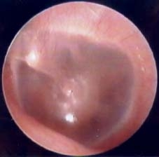
Normal

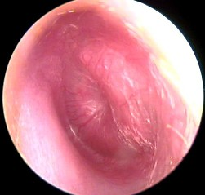
Otitis Media

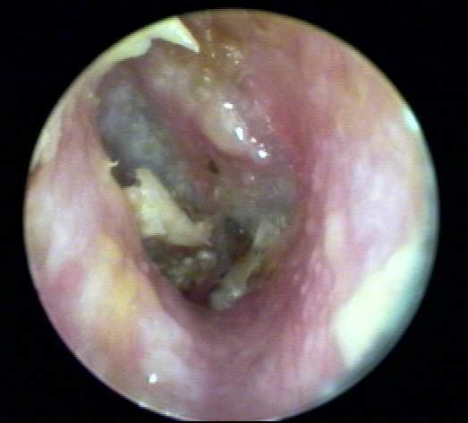
Otits Externa

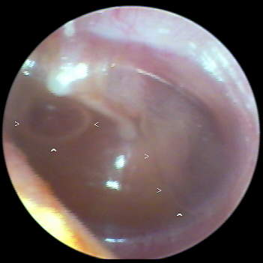
serous effusion

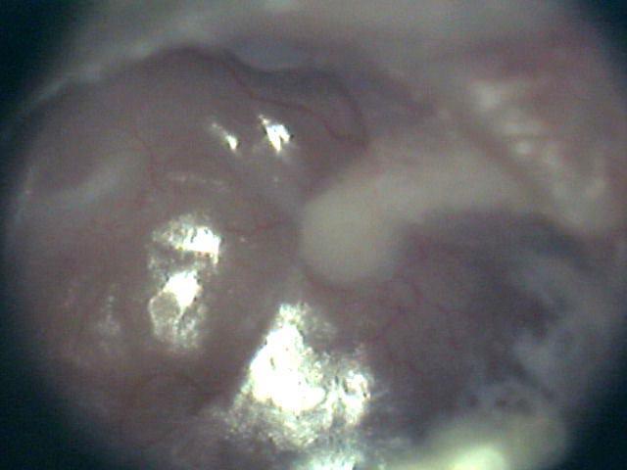
retracted drum
Anonymous Bates, p. 195-197
otitis media – tenderness behind ear caused by inflammation of the inner ear; red, bulging tympanic membrane.
otitis externa – movement of the auricle (pinna) and tragus painful; canal is often swollen, narrowed, moist, pale, and tender – may be reddened. If it is chronic, canal is often thickened, red, and itchy.
serous effusion – you will see an amber color tympanic membrane
retracted eardrum – unusually prominent short process and handle of the malleus is seen that looks more horizontal than normal.
Anonymous
Otitis media- the eardrum loses its landmarks, is red, and may bulge laterally toward the examiner’s eye. Conductive hearing loss and a lack of pain when moving the auricle or pushing on the tragus, and a dull or lacking light reflex may also be findings. Bates, p. 231 and 670

Otitis externa- Gentle movement of the pinna causes significant pain. Possible purulent material in the canal. Bates, p. 670

Serous effusion- is characterized by amber fluid behind the eardrum. Air bubbles may or may not be present. Bates, p. 231

Retracted drum- the drum is pulled medially, away from the examiner’s eye. The malleolar folds are tightened into sharp outlines. The short process often protrudes, and the handle of the malleus is pulled inward and looks shortened and more horizontal. Bates, p. 230
Michelle Swartz pg. 280
Otitis Media- a bacterial infection of the middle ear, most commonly in childern. The patient will have no pain while pulling onthe auricle and pushing on the tragus. The membrane is a fiery red, and bulges.
Otitis Externa-Pulling on the auricle and pushing on the tragus causes pain. Edema of the ear canel, erythema and a yellowish green discharge. Swimmers ear is an example.
Tabers 18th edition pg. 1746
Serous Effusion-the escape of serum into tissuses or a body cavity.
Retracted Drum-
Sung K, Swartz, p.279-82
a. Otitis media – injected, bulging, fiery red tympanic membrane; landmarks not visible
b. Otitis externa – a common inflammatory condition of the external ear canal with prominent symptoms of severe pain (otalgia) accentuated by manipulation of the pinna and especially by pressure of the tragus, edema of the external ear canal, erythema, and a yellowish green discharge.
c. Serous effusion – may present with yellowish orange tympanic membrane as a result of amber-colored fluid, visible landmarks, and air bubbles, immobile TM
d. Retracted drum – trapped air in the Eustachian tube which gets absorbed by tiny blood vessels in the middle ear and produces a vacuum which draws in or retracts the tympanic membrane. If not relieved can lead to serous effusion.
REX
Otitis media- the eardrum loses its landmarks, is red, and may bulge laterally toward the examiner’s eye. Conductive hearing loss and a lack of pain when moving the auricle or pushing on the tragus, and a dull or lacking light reflex may also be findings. Bates, p. 231 and 670

Otitis externa- Gentle movement of the pinna causes significant pain. Possible purulent material in the canal. Bates, p. 670

Serous effusion- is characterized by amber fluid behind the eardrum. Air bubbles may or may not be present. Bates, p. 231

Retracted drum- the drum is pulled medially, away from the examiner’s eye. The malleolar folds are tightened into sharp outlines. The short process often protrudes, and the handle of the malleus is pulled inward and looks shortened and more horizontal. Bates, p. 230

13. Describe the Weber and Rinne tests, and how they are used to distinguish between conduction hearing loss and sensorineural hearing loss (See Table 7-17).
Zen Seeker
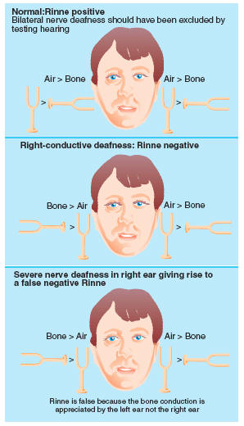
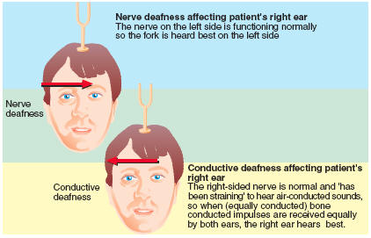
Anonymous Bates, p. 232-233
The Weber test consists of striking the tuning fork and placing it on the top of the pt’s head. In conductive hearing loss, the sound from the fork lateralizes to the impaired ear. In sensorineural loss, the sound lateralizes to the good ear – the impaired inner ear is less able to transmit impulses no matter how the sound reaches the cochlea.

The Rinne test consists of striking the tuning fork and holding it next to the pt’s ear (air conduction), then placing the fork just behind the ear (bone conduction). In conductive loss, vibrations bypass the problem of the air conduction through the external and middle ear, to reach the cochlea.
In sensorineural loss, The inner ear or cochlea is less able to transmit impulses no matter how the vibrations reach the cochlea – the pt won’t hear anything.
Anonymous
In Weber test, place the handle of the lightly vibrating tuning fork upon the midline of the skull and ask the patient where he hears it: on one or both sides. Normally the sound is heard in the midline or equally in both ears if nothing is heard, try again, pressing the fork more firmly on the head.

In conductive loss, sound lateralizes to the impaired ear. Because this ear is not distracted by room noise, it can detect the tuning forks vibrations better than normal. This lateralization disappears in an absolutely quiet room.

In sensorineural loss, the sound lateralizes to the good ear. The impaired inner ear or cochlear nerve is less able to transmit impulses no matter how the sound reaches the cochlea. The sound is therefore heard in the better ear.

In Rinne Test, first-place the base of the lightly vibrating tuning fork against the mastoid bone, behind the ear and level with the canal. When the patient can no longer hear the sound, quickly place the fork close to the ear canal and ascertain whether the sound can be heard again. Here the “U” of the fork should face forward, thus maximizing its sound for the patient. Normally the sound as heard longer air than through bone (AC >BC).

In conductive loss, Bone conduction lasts longer than or is equal to air conduction (BC>AC or BC=AC). While air conduction through the external or middle ear is impaired, vibrations through the bone bypass the problem to reach the cochlea. Causes include: Obstruction of the ear canal, otitis media, a perforated or relatively and mobilized eardrum, and osteosclerosis (a fixation of the ossicles by bony overgrowth).

In sensorineural loss, air conduction last longer than bone conduction (AC>BC). The inner ear or cochlear nerve is less able to transmit impulses regardless of how the vibrations reach the cochlea. The normal pattern prevails. Causes include: sustained exposure to loud noise, drugs, infections of the inner ear, trauma, tumors, congenital and hereditary disorders, and aging (presbycusis).
Michelle Swartz pg. 270-271
Rinne Test- this test compares air conduction with bone conduction.
Weber test- This test compares bone conduction in both ears and detrimines wether monaural impairment is neural or conductive in orgin. This tests test for hearing with background noise.
Sung K, Swartz, p.270-1 and Barkauskas, p.285 for table
The Weber test compares bone conduction in both ears by placing the base of a vibrating 512 Hz tuning fork on the vertex of the skull or the forehead. Hearing the sound or feeling the vibration in the middle is the normal response. In lateralization, sound is detected differently in each ear. Conduction loss is present if it lateralizes to the defective ear. Sensorineural loss is present if it lateralizes to the better ear.
The Rinne test compares air and bone conduction in both ears by placing the base of a vibrating 512 Hz tuning fork on the mastoid process. Once the patient can no longer hear the sound, the tines of the vibrating tuning fork is placed in front of the external auditory meatus of the same ear. The patient with no conduction loss will continue to hear the sound by air conduction.
Data from both tests are required to determine conductive or sensorineural loss.

Hearing | Weber Test | Rinne Test
Normal | Sound is heard equally well in both ears; no lateralization | Air conduction > Bone conduction (AC > BC)
Conduction loss | Sound lateralizes to defective ear b/c it is transmitted to bone rather than air | BC > AC
Sensorineural loss | Sound lateralizes to better ear | AC>BC but duration is less than normal

14. Describe or identify the common abnormalities which may be seen on nasal exam of:
the nasal mucosa
the nasal septum
frontal and maxillary sinus palpation and transillumination
Anonymous Bates, p. 199-200, 208
the nasal mucosa – reddened and swollen mucosa indicates viral rhinitis; pale, bluish, or red indicates allergic rhinitis; also can see swelling, bleeding, or exudate. Nasal mucosa is normally somewhat redder than oral mucosa. Ulcers or polyps may be seen.
the nasal septum – deviation, inflammation, or perforation; epistaxis – fresh blood or crusting.
frontal and maxillary sinus palpation and transillumination – tenderness (with pain, fever, nasal discharge) suggests acute sinusitis. Absence of glow on one or both sides suggests thickened mucosa or absence of the sinus.
Anonymous
Nasal mucosa – observe color swelling bleeding or exudate (clear, mucopurlulent, or purulent), in viral rhinitis the mucosa is reddened and swollen; in allergic rhinitis it may be pale, bluish, or red.

Nasal septum – observe deviation, inflammation or perforation (fresh blood or crusting may be seen),
causes of septal perforation include trauma, surgery, and intranasal use of cocaine or amphetamines.

Ulcers or polyps – polyps are pale, semitranslucent masses that usually come from the middle meatus. Ulcers may result from nasal use of cocaine.
Anonymous Bates p. 198-200
the nasal mucosa—abnormal color such as pale, bluish, or increased redness (normal color usually somewhat redder than oral mucosa; swelling; bleeding; exudate; ulcer; polyps.

the nasal septum—deviation, inflammation, perforation.

frontal and maxillary sinus palpation and transillumination
Tenderness to palpation with pain, fever, or discharge suggests acute sinusitis.
In transillumination see p. 208, 673, absence of glow suggests thickened mucosa or secretions (sinusitis).
Michelle Swartz pg. 277-278
Nasal Mucosa- Normal nasal mucosa membranes are dull red and moist and have a smooth, clean surface. Nasal mucosa is normally darker than oral mucosa. Inspect for exudate, swelling, bleeding, or trauma.
Nasal Septum-The septum should be staight with no deviation or perforations.
Sinus Palpation- If the patients sinus areas are tender on palpation this could indicate a sinus infection. If this occurs a transillumination test should be performed. In a dark room place a light source in the patients mouth. You should see a cresent shaped glow on each side, under the eyes. The glow should be equal. If one side contains fluid, a mass, or mucosal thickening there will be a decrease glow on that side.
Sung K, Swartz, p.277-8 and HEENT branching exam, p.C-7
a. The nasal mucosa – inspect for exudate, swelling, bleeding, trauma, crusting, ulcers, polyps. The color should be dull red, moist, and have a smooth, clean surface.
b. The nasal septum – deviations, perforations, kiesselbach plexus for signs of bleeding
c. Frontal and maxillary sinus palpation and transillumination – palpation may present with tenderness in person with sinusitis. Also transillumination should produce a decrease in glow indicating a loss of aeration associated with the accumulation of fluid, a mass, or mucosal thickening of the sinus.
REX
the nasal mucosa—abnormal color such as pale, bluish, or increased redness (normal color usually somewhat redder than oral mucosa; swelling; bleeding; exudate; ulcer; polyps.

the nasal septum—deviation, inflammation, perforation.

frontal and maxillary sinus palpation and transillumination
Tenderness to palpation with pain, fever, or discharge suggests acute sinusitis.
In transillumination see p. 208, 673, absence of glow suggests thickened mucosa or secretions (sinusitis). Swartz pg. 277-278

15. Describe or identify common abnormalities which may be found on examination of the mouth and pharynx.
Anonymous Bates, p. 200-202. See also Tables 7-18 – 7-21 pp.234-243
Teeth/Gums - Bright red edematous mucosa, ulcers, or papillary granulation
tissue.
Lips – Cyanosis, pallor
Oral Mucosa - Ulcers on labial mucosa.
Gums/ Teeth - Redness of gingivitis, black line of lead poisoning, swollen
interdental papillae in gingivitis.
Roof of mouth – Torus Palatinus (a midline lump)
Tongue and floor of mouth – Asymmetric protrusion suggests a lesion of Cranial
Nerve XII, cancer – most often on side or base of tongue
Pharynx – 10th nerve paralysis – soft palate fails to rise and uvula deviates to
opposite side.
Anonymous Bates pg. 202/05
dental caries gingivitis
canker sores leukoplakia
carcinoma of the tongue
enlarges tonsils tonsillitis
thrush pharingitis
Michelle Swartz pg.286
The oral cavity consits of buccal mucosa, lips, tongue, hard and soft palates, teeth, and salivary glands.
Sung K, Swartz, p.294-310 and HEENT Branching Exam, p.C-7,8
a. Lips – color, moisture, lumps, ulcers, cracking
b. Buccal mucosa – color, lesions
c. Teeth and gums – inflammation, swelling, bleeding, retraction, discoloration, loose or missing teeth, and dental caries
d. Tongue – asymmetry, lesions (e.g. hairy leukoplakia, candidiasis)
e. Palate – lumps (torus palatinus), lesions (pseudomembrananous candidiasis, palatal petechiae)
f. Tonsils – presence, size, color, pus, symmetry
REX Swartz 294-304
Lips – Cyanosis, pallor, lesions
Oral Mucosa – Ulcers, inflammation, asymmetry, discoloration, trauma
Gums/ Teeth - Redness of gingivitis, recession, bleeding, dental caries, malocclusions
Palate- ulceration, lesions, masses, fungal infection, cleft palate
Tongue and floor of mouth – ulcers, lesions, masses, infections
Pharynx- infection, swelling, erythema, masses, ulceration, discharge.

16. List 6 characteristics which can be noted in describing lymph nodes.
Anonymous Bates, p. 203
Size, shape, delimitation (descrete or matted together), mobility, consistency, and any tenderness.
Anonymous
size shape consistency
deliniation mobility tenderness
Tim B : Schwartz, Ch. 8, pgs 185-186
Size, mobility, consistency, tenderness, position and location or temperature (I’m guessing on temperature/location because I couldn’t find the 6th).
REX Bates, p. 203
Size, shape, delimitation (discrete or matted together), mobility, consistency, and any tenderness.

17. Identify the potential significance of tender nodes; of hard or fixed nodes.
Anonymous
Lymphadenitis refers to lymph node enlargement, with or without tenderness. Any pathoge; bacterial, viral, protozoal, rickettsial, or fungal; can cause lymphadenitis.

Hard or fixed nodes indicate passing infection. With resolution of the primary cause of infection, lymph node enlargement usually passes. But firm, nontender lymphadenopathy sometimes persists. Hot compresses usually help acutely painful nodes. Sometimes surgical drainage is required. (Merek Manual pg. 58 16th ed.)
Anonymous Bates, p203
Tender nodes suggest inflammation; hard or fixed nodes suggest malignancy.
Tim B: Schwartz, Ch.8, pg 186
Tender nodes are suggestive of infection, hard or fixed nodes are consistent with a malignancy.
Rigo Swartz, pg. 186
Tender lymph nodes are suggestive of inflammation, whereas fixed, firm nodes are consistent with malignancy.

18. Identify the potential significance of tracheal deviation.
Anonymous
Tracheal deviation may suggest a mass in the neck - May also be associated with mediastinal mass, atelectasis, or large pneumothorax. Bates, p204
Tim B: Schwartz, Ch. 12, pg 337
Tracheal deviation is suggestive of a mass or neoplasm causing the displacement.
RigoSwartz, pg. 337
A shift of the mediastinum [(Bates) related to: Atelectasis, pleural effusion, pneumothorax] can displace the trachea to one side. A neck mass (enlarged unilateral thyroid, goiter, or tumor) can deviate the trachea.

19. Define goiter.
Anonymous Bates, p. 204
A general term for enlarged thyroid gland.
Anonymous
Goiter is the term used for an enlarged thyroid gland.
Tim B: Stevens&Lowe, Ch. 16, pg. 332
Goiter is defined as any enlargement of the thyroid gland causing swelling in the neck. Etiology can be metabolic or hormonal and may present as diffuse swelling or palpably nodular.
Rigo Taber’s
- An enlargement of the thyroid gland, possibly due to a lack of iodine in the diet, thyroiditis, inflammation from infection, tumors, or hyperfunction or hypofunction of the thyroid gland.

20. Describe physical characteristics of the thyroid in normal and abnormal states.
Anonymous Bates, p. 204-205. See also Table 7-22 p.244
The thyroid gland is normally small and symmetrical on both sides. It is usually smooth (no lumps or bumps) and is more easily palpable on slender people. In abnormal states, a goiter may be present (enlarged thyroid), lower boarder rises and looks less symmetrical with swallowing, nodules may be palpated, localized systolic or continuous bruits may be heard when auscultated.
Anonymous
In it’s normal physical state; the thyroid should barely be palpable. (If at all)
In it’s abnormal state; the thyroid gland is swollen and is called a goiter. An enlarged thyroid gland can be seen and felt.
Tim B: Schwartz, Ch. 8, pg 182
A normal thyroid lies inferior to the cricoid cartilage of the larynx and consists of two lobes attached by an isthmus that wrap around the front of the trachea. The normal thyroid is firm, non-nodular and somewhat small in size.
An abnormal thyroid can be enlarged, soft, tender, nodular and extending inferiorly beyond normal border (into the thorax).
Rigo Swartz, pg.187
The normal thyroid has a consistency of muscle tissue. Unusual hardness is associated with cancer or scarring. Softness, or sponginess, is often seen with a toxic goiter. Tenderness of the thyroid gland is associated with acute infections or with hemorrhage into the gland. A bruit may be ascultated in an enlarged thyroid indicating enlarged vessels seen with toxic goiter.

21. Define the following terms:
ptosis
ectropion
entropion
Anonymous
PTOSIS - prolapse of the upper eyelid.
ECTROPION - outward turning of the lower eyelid, exposing the palprebal conjunctiva. eye does not drain properly and tearing occurs.
ENTROPION - an inward turning of the lid margin. The lower lashes when turned in irritate the conjunctivaand lower cornea
Janelisa Swartz 212
ptosis drooping of the eyelid
ectropion a turning outwards of the eyelid margin
entropion a turning inwards of the lid margin such that the eyelashes abrade the cornea and eyeball
Rigo
Ptosis - Taber’s Drooping of the upper eyelid from paralysis
Ectropion - Taber’s Eversion of an edge or margin, as the edge of an eyelid.
Entropion - Taber’s An inversion or turning inward of an edge, esp. the margin of the lower eyelid.

22. Define the following terms:
pinguecula
sty (hordeolum)
chalazion
xanthelasma
episcleritis
dacryocystitis
Anonymous Bates pgs 214-215
PINGUECULA - A yellowish, somewhat triangular nodule in the bulbar conjunctiva on either side of the iris. Harmless, usually appears first on the nasal side, then temporal.
STY(HORDEOLUM) - Painful, red, tender infx around an eyelash follicle. Looks like a pimple on the lid margin.
CHALAZION - Chronic inflammatory lesion involving a meibomian gland. A beady nodule. Usually painless.
XANTHELASMA - Slightly raised yellowish well-circumscribed plaques in the skin along the nasal portions of one or both eyelids. Can accompany lipid disorders.
EPISCLERITIS - Localized ocular redness from inflammation of the episcleral vessels. Usually benign and self-limited. May be nodular or may only show redness and dilated vessels.
DACRYOCYSTITIS - Inflammation of the lacrimal sac. A swelling btw the lower eyelid and nose. Acute inflammation is painful, red and tender. Chronic inflammation is associated w/ obstruction of the nasolacrimal duct.
Janelisa
pinguecula Swartz 216 whitish-yellow, triangular, nodular growth on the bulbar conjunctiva adjacent to the corneal scleral junction (limbus)
stye (hordeolum) Swartz 215 localized abscess in an eyelash follicle and is caused by a staph infection
chalazion Swartz 212 granulomatous reaction to inspissated (Webster’s thickened, as by evaporation; condensed) secretions of the meibomian glands in the lid
xanthelasma Swartz 214 yellowish plaques caused by lipid deposition in the periorbital skin
episcleritis Swartz 218 benign, usually painless, commonly recurring disorder frequently affection both eyes of young adults; noninfectious inflammation that is subconjuctival yet superficial to the underlying sclera; affected area may be either flat and diffuse or localized and nodular; cause is unknown but occurs in patients with IBS, herpes zoster, collagen vascular disease, gout, syphilis, and RA.
Dacryocystitis Swartz 226 inflammation of lower lacrimal passages usually seen in infants or older adults; causes include congenital anomalies, infection, and stenosis of the lacrimal duct
Deanna
• Pinguecula-whitish-yellow, triangular nodular growth on the bulbar conjunctiva adjacent to the corneal-scleral junction pg216
• Sty (hordeolum)-localized abscess in an eyelash follicle and is caused by a staphylococcal infection. Pg215
• Chalazion-granulomatous reaction to inspissated (thickened) secretions of the meibomian glands in the lid. Pg212
• Xanthelasma-yellowish plaques commonly associated with lipid abnormalities and are caused by lipid deposition in the periorbital skin. Pg214
• Episcleritis-benign, usually painless, it is a noninfectious inflammation that is subconjunctival yet superficial to the underlying sclera. Pg218
• Dacryocystitis-inflammation of the lower lacrimal passages usually seen in infants or older individuals. Pg226

23. Describe the following common causes and presentation of red eye:
conjunctivitis
subconjunctival hemorrhage
Anonymous
Conjunctivitis: Inflammation of the conjunctiva usually associated with a discharge and usually no pain. Classified as non-infectious or infectious. Source: Noble pg 1643.

Subconjunctival hemorrhage (SCH): is caused by the rupture of the small subconjunctival vessels that strain the bulbar conjunctiva. Commonly minor trauma or violent valsalva maneuvers can cause SCH. Also can be caused by HTN and coagulopathies.
Janelisa Bates 4th ed. 191
conjunctivitis caused by bacterial, viral, or other infections; allergy; irritation. Presents with redness that tends to be maximal peripherally, mild discomfort; watery, mucoid, or mucopurulent discharge
subconjunctival hemorrhage may result from traum, bleeding disorders, or a sudden increase in venous pressure, as from cough. Presents with a homogeneous, sharply demarcated red area from leakage of blood outside the vessels, with no pain or discharge
Deanna
• Conjunctivitis-inflammation of the conjunctiva. It can be caused by a bacterial or viral infection, allergies or environmental factors. Presents with red eyes, thick discharge, sticky eyelids in the morning and inflammation without pain which are usually caused by a bacteria. Mosby’s dict. Pg418 , Ballweg 174
• Subconjunctival hemorrhage-Fig 9-26 Swartz 216. It is bleeding under the conjunctiva and presents as a red spot.

24. Define or identify the following:
corneal arcus (also known as arcus senilus)
corneal scar
pterygium
cataracts
Anonymous
Corneal scar: is a superficial grayish white opacity in the cornea secondary to an old injury or inflammation. Source: Bates pg 216.

Pterygium: Is a triangle wedge of fibrovascular tissue that begins on the epibulbar conjunctiva and grows slowly onto the cornea. Ultraviolet exposure seems to be the primary factor and prevalence directly related to the proximity to the equator. Source: Noble pg 1699 and Bates pg 216.

Cataracts: An opacity (clouding) of the lens and is seen through the pupil, causing decreased vision. Classified in many ways including cause and location. Source: Bates pg 216.
Janelisa
corneal arcus (also known as arcus senilus) Swartz 219 whitish ring at the perimeter of the cornea usually appearing with age; in patients younger than 40, it may be an indication of hypercholestermia
corneal scar Bates 4th ed. 192 superficial grayish white opacity in the cornea, secondary to an old injury or inflammation; size and shape is variable
pterygium Swartz 216 a more vascular growth on the bulbar conjunctiva that begins at the medial canthus and extends beyond the corneal-scleral junction to the cornea; typically triangular, it may cause astigmatism or even decreased vision if it extends across the pupillary margin
cataracts Swartz 225 any opacification of the lens whether it causes reduced visual acuity or interferes with the patient’s everyday life. Bates 4th ed. 192 can be viewed only through the pupil
Deanna
• Corneal arcus (arcus senilus)-infiltration of degenerative material around the limbus. Swartz 200
• Corneal scar (keratoconus)-abnormality of shape of the cornea. The cornea protrudes as a cone with the apex becoming thin (Monson’s sign). Swartz pg220
• Pterygium-vascular growth on the bulbar conjunctiva. The triangle shaped fibrovascular connective tissue may cause astigmatism or decrease vision. Swartz pg216
• Cataracts-opification of the lens that causes reduced visual acuity and the red reflex is absent during ophthalmoscopy. Swartz 225

25. Define the following:
Anisocoria
Argyll Robertson pupils
Oculomotor Nerve paralysis
Strabismus
Anonymous
Anisocoria – Discrepancy of pupillary size (unequal). May be an indication of neurological injury or disease. Source: Noble pg 1632.

Argyll Robertson pupils – Small, unequal and irregular pupil which do not react to light but constrict on accommodation. Seen in patients with tertiary syphilis, diabetes and in meningoradiculitis of Lyme disease. Source: Noble pg 1632.

Oculomotor Nerve paralysis – Three paired cranial nerves are responsible for innervating the extra ocular muscles and producing eye movements. A dysfunction in any of these nerves can cause diplopia in any one positions of gaze. Conditions such as aneurysm, fistula, meningioma, metastatic disease, infection, inflammation, physical injury during head trauma or ocular injury, strokes and demyelinating diseases can be the underlying cause. Source Noble pg 1718

Strabismus – Deviation of the eyes from their normally conjugate position because of weakness of a muscle controlling the position of one eye. May be classified into 2 groups (1) non-paralytic and (2) Paralytic. Different forms of strabismus include esotropia (one eye turns inward), exotropia (one eye turns outward), and hypertropia (upward deviation of one eye). Source: Bates pg 218.
Janelisa
Anisocoria Swartz 220 unequal pupil size; normal in 5% of population; may be indicative of neurologic disease or medication side effect
Argyll Robertson pupils Swartz 221 pupils constricted 1-2 mm that reacts to accommodation but is nonreactive to light; occurs in association with neurosyphilis
Oculomotor Nerve paralysis Bates 4th ed. 194 dilated pupil that reacts neither to light nor with near effort may result from injury to the oculomotor nerve. Ptosis and deviation of the eye laterally may be associated
Strabismus Swartz 209 deviated or crossed eye; the nonalignment of the eyes in such a way that the object being observed is not projected simultaneously on the fovea of each eye
Howie SWARTZ p. 220,221,209
Anisocoria--unequal pupil size; normal in 5% of population; may be indicative of neuro disease or medication side effect
Argyll Robertson pupils--pupils constricted 1-2 mm that reacts to accommodation but is non-reactive to light; occurs in association with neurosyphilis
***Oculomotor Nerve paralysis (Bates 4th ed. 194) dilated pupil that reacts neither to light nor with accommodation, may result from injury to the oculomotor nerve CN III. Ptosis and deviation of the eye laterally may be present.
Strabismus -deviated or crossed eye; the nonalignment of the
eyes in such a way that the object being observed is not projected
simultaneously on the fovea of each eye.
***from Alex’s website, couldn’t find in SWARTZ, don’t have BATES yet

26. Describe the normal appearance and variations of the
optic disc. Be able to describe or identify a picture of the typical findings of
papilledema and glaucomatous cupping.
Anonymous
Papilledema; Venous Stasis leads to engorgment and swelling. The color is pink, hyperemeic. The disc vessels are more visible, more numerous,and curve over the borders of the disc. The disc itself is swollen with the margins blurred. The physiologic cup is not visible.

Glaucomatous cupping; Increased pressure within the eye leads to increased cupping (backward depression of the disc) and atrophy. The base of the enlarged cup is pale. The physiologic cup is enlgarged, occupying more than half the discÕs diameter, at times extending to the edge of the disc. Retinal vessels sink in and under it, and may be displaced nasally.
Anonymous
The optic disc normally appears to have the color yellowish orange to creamy pink and the disc vessels are tiny. Disc margins sharp. The physiologic cup is located centrally or somewhat temporally. It may be conspicuous or absent. Its diameter from side to side is usually less than half that of the disc.
Papilledems is caused by venous stasis, which leads to engorgement and swelling. The color is pink, hyperemic. Disc vessels more visible, more numerous, curve over the borders of the disc. Disc swollen with margins blurred. The physiologic cup is not visible.
Glaucomatous Cupping is caused by increased pressure within the eye leads to increased cupping (backward depression of the disc) and atrophy. The base of the enlarged cup is pale. The physiologic cup is enlarged, occupying more than half of the disc’s diameter, at times extending to the edge of the disc. Retinal vessels sink in and under it, and may be displaced nasally.
Greg R. Swartz pg. 229. The normal disc should be round or slightly oval with the long axis usually vertical and with sharp borders. The nasal border is normally slightly blurred. The disc is pinkish in light-skinned individuals and yellowish-orange in darker-skinned individuals. The relative pallor of the optic disc is caused by the reflection of light from the myelin sheaths of the optic nerve. In the center of the normal optic disc, there is a funnel-shaped depression known as physiologic cupping. The cup is the portion of the disc that is central, lighter in color, and penetrated by the retinal vessels. see fig 9-57. Bates’ pg. 184 you need to look at this page. Papilladema- Venous stasis leads to engorgement and swelling the optic disc color is pink, hyperemic. Disc vessels more visible, more numerous, curve over the borders of the disc. Disc is swollen with margins blurred. The physiologic cup is not visible. Glaucomatous Cupping- Increased pressure within the eye leads to increased cupping (backward depression of the disc) and atrophy. The base of the enlarged cup is pale. The physiologic cup is enlarged, occupying more than half of the disc’s diameter, at times extending to the edge of the disc. Retinal vessels sink in and under it, and may be displaced nasally.
Deb B./Swartz,pg. 229: Optic disc should be round or slightly oval with long axis usually vertical and with sharp borders, it is pinkish(in light skinned people) yellowish-orange (in darker skin people), in center there’s funnel-shaped depression “physiologic cupping” (cup is lighter in color and central portion of disc)/ Normal ratio of cup-disc diameter varies from 0.1 to 0.5
Papilledema=pg.239 swelling of optic disc, see blurring of optic disc in assoc. with loss spontaneous retinal venous pulsation, hyperemia of disc, hemorrhages and exudates of disc, and dilated tortuous retinal veins/ See picture pg. 242 (Swartz)
Glaucomatous cupping=Swartz pg. 234-235 see picture at bottom of page 234, see difference in optic cup size between two eyes (cupping=loss of nerve substance), visual field changes
Howie SWARTZ p. 229 Has picture MOSBY p. 290-291 Mosby’s Guide to Physical Examination, 4th ed.
round or slightly oval, sharp borders, pinkish in light skinned persons, yellow-orange in dark skinned persons, in center is funnel shaped depression—cup. Cup to disc size ratio varies from 1/10 to ½.

papilledema—loss of definition of optic disc, no longer has sharp borders, initially seen at the top and bottom, then sides

glaucomatous cupping—disc appears whiter than normal, vessels displaced nasally. Increased pressure within the eye leads to increased cupping (backward depression of the disc) and atrophy. The base of the enlarged cup is pale. The physiologic cup is enlarged, occupying more than half the disc’s diameter, at times extending to the edge of the disc. Retinal vessels sink in and under it, and may be displaced nasally.

27. Describe the normal renal arteries and arteriovenous crossings. Describe the changes that occur with hypertension including:
Narrowed light reflex
Copper wire arteries
Silver wire arteries
Anonymous
The normal arterial wall is transparent. Only the column of blood within it can usually be seen. The normal light reflex is narrow, about ¼ the diameter of the blood column. Because the arterial wall is transparent, a vein crossing beneath the artery can be seen right up to the column of blood on either side.
Narrowed light reflex
In hypertension, the arteries may show areas of focal or generalized narrowing. The light reflex is also narrowed. Over many months or years, the arterial wall thickens and becomes less transparent.
Copper wire arteries
Sometimes the arteries, especially those close to the disc, become full and somewhat tortuous and develop an increased light reflex with a bright coppery luster. Such a vessel is called a copper wire artery.
Silver wire arteries
Occasionally a portion of a narrowed artery develops such an opaque wall that no blood is visible within it. It is then called a silver wire artery. This change typically occurs in the smaller branches.
Greg R. Bates’ pg. 185 Must see this for illustration. The normal arterial wall is transparent. Only the column of blood within it usually can be seen. The normal light reflex is narrow-about one fourth the diameter of the blood column. In hypertension, the arteries may show areas of focal or generalized narrowing. The light reflex is also narrowed. Over many months or years, the arterial wall thickens and becomes less transparent. In copper wire artery, sometimes the arteries, especially those close to the disc, become full and somewhat tortuous and develop an increased light reflex with a bright coppery luster (see Swartz pg. 231 fig 9-61 for photo). In silver wire artery, occasionally a portion of a narrowed artery develops such an opaque wall that no blood is visible within it. This change typically occurs in the smaller branches.
Deb B./Swartz, pg. Normal retinal arteries=central artery enters globe thru physiologic cup, divides within cup and again on surface (giving rise to 4 main branches), normal vessel wall invisible with its thin light reflex
Arteriovenous crossings=crossing of arteries and veins occurs within 2 disc diameters from the disc/Also see Bates, pg.185
Changes in hypertension: Narrowed light reflex-vessel may have focal or gen. areas narrowing or spasm, causing light reflex narrow/ Copper wire arteries- with time, vessel wall becomes thickened and sclerotic, and widening of light reflex to greater half diameter of column of blood, reflex develops orange metallic appearance/
Silver wire arteries Bates, pg. 185 Portion of narrowed artery develops such an opaque wall that no blood is visible within it. (typically in smaller branches)
Howie SWARTZ, p.230, 231
The normal arterial wall is transparent. Only the column of blood within it can usually be seen. The normal light reflex is narrow, about ¼ the diameter of the blood column. Because the arterial wall is transparent, a vein crossing beneath the artery can be seen right up to the column of blood on either side.
Narrowed light reflex
In hypertension, the arteries may show areas of focal or generalized narrowing. The light reflex is also narrowed. Over many months or years, the arterial wall thickens and becomes less transparent.
Copper wire arteries
Sometimes the arteries, especially those close to the disc, become full and somewhat tortuous and develop an increased light reflex with a bright coppery luster. Such a vessel is called a copper wire artery.
Silver wire arteries
Occasionally a portion of a narrowed artery develops such an opaque wall that no blood is visible within it. It is then called a silver wire artery. This change typically occurs in the smaller branches.

28. For each of the following identify physical findings and cause:
Superficial retinal hemorrhages
Deep retinal hemorrhages
Preretinal hemorrhage
Microaneurysms
Neovascularization
Anonymous
Table 7-12. For each of the following identify physical findings and causes:
a. Superficial retinal hemorrhages:
Small, lenear, frame shaped, red streaks in the fundi.
Cause: hypertension, papilledema, occlusion of retinal vein, among others.
b. Deep retinal hemorrhages:
Small rounded slightly irregular red spots that are sometimes called dot or blot hemorrhages.
Cause: Diabetes mellitus is a common cause.
c. Preretinal hemorrhages:
Typically larger than a retinal hemorrhage. In an erect patient, red cells settle, creating a horizontal line of demarcation between plasma above and cells below. They develop when blood escapes into the potential space between retina, and vitreous and obscures any underlying vessels.
Cause: include sudden increase in intracranial pressure.
d. Microaueurysms:
Tiny, round, red spots seen commonly but not exclusively in and around the macular area. Minute dilatations of very small retinal vessels, but the vascular connections are too small to be seen ophthalmoscopically.
Cause: characteristic of diabetic retinopathy, but not specific to it.
e. Neovascularizations:
Refers to the formation of new blood vessels. They are more numerous, more tortuous, and narrower than other blood vessels in the area and form disorderly-looking red arcades.
Cause: late, proliferative stage of diabetic retinopathy.
Greg R. Bates’ pg. 186 Must see this for illustration. Superficial retinal hemorrhages are small, linear, flame-shaped, red streaks in the fundi. Sometimes the hemorrhages occur in clusters and then simulate a larger hemorrhage, but the linear streaking at the edges shows their true nature. Superficial hemorrhages are seen in severe hypertension, papilledema, and occlusion of the retinal vein. An occasional superficial hemorrhage has a white center consisting of fibrin. White-centered retinal hemorrhages have many causes. Deep retinal hemorrhages are small, rounded, slightly irregular red spots that are sometimes called dot or blot hemorrhages. They occur in a deeper layer of the retina than flame-shaped hemorrhages. Diabetes mellitus is a common cause. Preretinal hemorrhage (subhyaloid hemorrhage) develops when blood escapes into the potential space between retina and vitreous. This hemorrhage is typically larger than retinal hemorrhages. Because it is anterior to the retina, it obscures any underlying retinal vessels. In an erect patient, red cells settle, creating a horizontal line of demarcation between plasma above and cells below. Causes include a sudden increase in intracranial pressure (see Swartz pg 238 fig 9-75). Microaneurysms are tiny, round, red spots seen commonly but not exclusively in and around the macular area. They are minute dilatations of very small retinal vessels, but the vascular connections are too small to be seen opthalmoscopically. Characteristic of diabetic retinopathy but not specific to it. Neovascularization refers to the formation of new blood vessels. They are more numerous, more tortuous, and narrower than other blood vessels in the area and form disorderly looking red arcades. A common cause is the late, proliferative stage of diabetic retinopathy. The vessels may grow into the vitreous, where retinal detachment or hemorrhage may cause loss of vision (see Swartz pg. 238 fig 9-73/74)).
Deb B./Bates, pg. 186: Superficial retinal hemorrhages=small, linear, flame shaped, red streaks in fundi (posterior part of eye), shaped by superficial bundles of nerve fibers that radiate from optic disc. Cause by severe HTN, papilledema, occlusion of retinal vein.
Deep retinal hemorrhages: (Bates, pg. 186)=small, rounded, slightly irregular red spots sometimes called dot or blot hemorrhages/Caused often by DM.
Preretinal hemorrhage: (Bates, pg. 186)=larger than retinal hemorrhages, in erect patient, red cells settle, creating horizontal line of demarcation between plasma above and cells below/Cause by sudden increase in intracranial pressure.
Microaneurysms: (Bates, pg.186)=tiny, round red spots seen commonly but not exclusively in and around macular area/Characteristic of diabetic retinopathy.
Neovascularization:(Bates,pg.186)=more numerous, more tortuous, and narrower than other blood vessels in area and form disorderly looking red arcades/Causes=late, proliferative stage of diabetic retinopathy.

29. For each of the following identify physical findings and cause:
Cotton wool patches
Hard exudates
Drusen
Anonymous
Table 7-13. For each of the following identify findings and cause:
a. Cotton wool patches:
White or grayish, ovoid lesions with irregular (thus “soft”) borders. Moderate in size but usually smaller than the disc.
Cause: infracted nerve fibers; and, are seen with hypertension
b. Hard exudates:
Creamy or yellowish, often bright lesions with well defined (thus “hard”) borders. They’re small and round but may coalesce (fuse, run together) into larger irregular spots. Often cluster in circular, linear, or star-shaped patterns.
Cause: diabetes, and hypertension
c. Dursen:
Yellowish round spots that vary from tiny to small. Haphazard distribution, but may concentrate at the posterior pole.
Cause: may occur with normal ageing, but may accompany other conditions, including age-related macular degeneration.
Greg R. Bates’ pg. 187 Must see this for illustration. Cotton-Wool patches are white or grayish, ovoid lesions with irregular (“soft”) borders. They are moderate in size but usually smaller than the disc. They result from infracted nerve fibers and are seen with hypertension and many other conditions (see Swartz pg 231 fig 9-63). Hard exudates are creamy or yellowish, often bright lesions with well-defined (“hard”) borders. They are small and round but may coalesce into larger irregular spots. They often occur in clusters or in circular, linear, or star-shaped patterns. Causes include diabetes and hypertension. Drusen are yellowish round spots that vary from tiny to small. The edges may be hard or soft. They are haphazardly distributed but may concentrate at the posterior pole. Drusen appear with normal aging but may also accompany various conditions, including age-related macular degeneration.
Deb B./Swartz, pg.231-232:Cotton wool patches=white lesions may appear as soft, cotton wool areas or may be dense, caused by infarctions of nerve fiber layer of retina, freq. assoc. with HTN or DM
Hard exudates Bates, pg.187=creamy or yellowish, bright lesions with well defined borders, small and round, but may coalesce into larger irreg. spots, often occur in clusters/Cause=DM and HTN
DrusenSwartz,pg.232=round, well circumscribed whitish lesions, variable pattern, symmetrical in both eyes, deep to retinal blood vessels, same cause as above(infarct. Nerve fiber layer, assoc. with HTN, DM)

30. Describe the differences between the normal fundus of a fair-skinned person and a dark-skinned person, the normal fundus of an older person, and the changes that occur with hypertension.
Anonymous
Table 7-14. Describe the differences between the normal fundus of a fair-skinned person and a dark skinned-person, the normal fundus of an older person, and changes that occur with hypertension.
Fair-skinned:
Inspect the macular area. A darker fovea is just discernible; no light reflex is visible in this subject. The fundus has a striped, or tessellated, character, especially in lower fields. This come from normal choroidal vessels that are unobscured by pigment.
Dark-skinned:
The ring around the fovea is a normal light reflection. The fundus has a
grayish brownish, almost purplish cast, which comes from pigment in the retina and the coroid. This pigment typically obscures the choroids vessels, and no tessellation is visable.
Older person: Normal
The blood vessels are straighter and narrower than those in younger persons, and the choroidal vessels can be seen easily. The optic disc may be less pink, and pigment may be seen temporal to the disc and in the macular area.
Hypertensive retinopathy:
The nasal border of the optic disc is blurred. The light reflexes from the arteries just above and below the disc are increased. Venus tapering can be seen.
Greg R. Bates’ pg. 189-190 You really need to see the photos to understand this one.
Deb B./Bates, pg. 189 Fundus of fair skin=color of fundus is lighter, fovea barely discernible, note striped character of fundus esp. in lower field (this comes from normal choroidal vessels that are unobscured by pigment)
Fundus of dark skin=fundus is grayish brownish, almost purplish cast, ring around fovea is normal light reflection. Pigment obscures the choroidal vessels.
Fundus of older person(Bates,pg.190)=blood vessels are straighter and narrower than in younger pt., choroidal vessels can be seen easily.
Changes with HTN=nasal border of optic disc is blurred, light reflexes from arteries just above and below disc are increased, see venous tapering at the A-V crossing

31. Describe the findings associated with squamous cell carcinoma and basal cell carcinoma of the ear.
April T. – Bates’ Has the best source p. 192 good pictures and simple explanations.
Also, Patho/ Stevens p. 237 and 499-500, Swartz p. 143.
Squamous cell carcinoma- Common in fair skin people exposed to sunlight. Appears as raised crusted border with central ulceration. Biopsy confirms dx. Spreads locally. Occasional mets to the regional lymph nodes.
Basal cell carcinoma- Raised nodule with lustrous surface and vessels. Slow growing, common malignancy, rare mets. Also, fair skinned people and exposer to sunlight
EChing, Swartz, P143
Squamous cell carcinona is a malignant neoplasm of keratocytes in the epidermis & is locally invasive into the dermis. The tumor results in a scaling, crusting nodule or plaque that can ulcerate & bleed. See figure 7-28 A
EChing, Stevens & Lowe, P499-500
Two patterns of invasive squamous carcinoma of the skin may arise in pre-existing epidermal dysplastic lesions:
1) Actinic keratosis (solar keratosis)- arises as irregular plaques or patches (frequently multiple), up to 1cm in diameter, with a rough, hard hyperkeratotic surface.
2) Squamous carcinoma in situ (intraepidermal carcinoma)- lesions spear as flat or raised reddish-brown plaques, sometimes with surface keratinous scale, & occasionally with focal ulcertaion. See “Color Atlas & Synopsis of Clinical Dermatology” by Fitzpatrick, Johnson, Wolff. Fig 9-7, P259 & Fig 9-16, P 265.
EChing, Swartz, P143-144
Basal cell carcinoma is a malignant neoplasm of the basal cells of the epidermis & is the most common skin malignancy. The epidermis is thickened, & the dermis may be invaded by the malignant basal cells. It may manifest as a lesion with a pearly, rolled, well-definied margin & a central ulcerated depression.
EChing, Stevens & Lowe, P499
Nodular basal-cell carcinoma- presents as a firm, raised, nodule, often showing central ulceration, with a raised, pearly edge, which may show numerous telangiectatic vessels. It is composed of clusters of small, dark cells resembling those of the basal layer of the epidermis. The edge of each cluster often shows a regular palisaded pattern. In the larger more protuberant lesions, cystic change is frequently seen.
Morpheic basal-cell carcinoma- appears as a flat, thickened, whiteish or yellowish plaque, which may be sunken & firm, with focal areas of ulceration.
Superficial basal-cell carcinoma- usually appears as a flat, red plaque, often with an irregular edge. Sometimes there are raised areas within the tumor, representing the development of a nodular basal-cell carcinoma within the pre-existing superficial lesion.
NormColor Atlas of clinical derm Pg. 257-265Stevens & Lowe Pg. 237-238
Squamous cell carcinoma: Often develops on area’s of the body constantly exposed to the sun, such as the ears, nose and face and have a high occurrence rate in the elderly. These are often single lesions on the pinna and or auricle of the ear that tend to be dark in color and crusted or ulcerated.

Basal cell carcinoma: Is the most common form of skin cancer. It tends to be locally invasive but has limited capacity to metastasize. This carcinoma is similar to the squamous cell in that fair skinned people have a higher incidence and that its distribution on the face and head are equal.

32. Describe the physical exam findings associated with the following:
Normal ear drum
Perforation of the eardrum
Tympanoslerosis
Serous effusion
Acute otitis media
Bullous myringitis
April T.
Normal ear drum Swartz p. 274, F. 10-16 The TM should appear intact, ovoid, semitransparent, pearly-gray. Lower 4/5 is called the pars tensa and the upper 1/5 the pars flaccida. The malleus should be seen in the center of the pars tensa. The TM lies oblique to the external canal and the superior margin is closer to the examiners eye.
Perforation of the eardrum Swartz p. 280 (f. 10-28) Usually result from infection. Maybe marginal or central. Marginal more serious, may lead to cholesteatoma. Visible hole in the TM occasionally internal land marks visible. In chronic perforation the margins is smooth epithelium with tympanosclerosis.
Tympanoslerosis- Caused by deposition of hyline material and calcification within the layers of the TM. Chalky with patterns with irregular margins..
Serous effusion-Amber fluid behind the Tm is characteristic a fluid level, viral cause, URI and atmospheric pressure changes.
Acute otitis media- Bacterial infection cause. The TM reddens, loses its landmarks, and bulges laterally.
Bullous myringitis- viral infection, ear ache with a blood tinged discharge and a conductive learing loss are all findings.
EChing, Swartz, P274-275 Normal ear drum- the tympanic membrane (TM) should appear as an intact, ovoid, semitransparent, pearly gray membrane at the end of the canal. The normal position of the TM is oblique to the external canal. The superior margin is closer to the examiner’s eye. In the normal ear, the handle of the malleus attached to the TIM is the primary landmark. Keratin patches appear as multiple, discrete white patches on the TM of all normal membranes.
Swartz, P280-281 Perforation of the eardrum- may be central or marginal & may result from either otitis media or trauma. A central perforation does not involve the margin or annulus of the TM; a marginal perforation involves the margin. Fig 10-28, Fig 10-31 (chronic TM perforation)
Swartz, P274-75 Tympanoslerosis- dense, white plqaques on the TM, caused by deposition of hyaline material & calcification within the layers of the TM. The classic horseshoe shape of tympanosclerosis is seen on the TM. Fig 10-17 on P275.
Swartz, P282 Serous effusion (serous otitis media) – the TM appears yellowish orange as a result of the amber-colored fluid, & the landmarks are clearly seen as the membrane is retracted against these structures. Partial obstruction of the Eustachian tube produces air bubbles or an air-fluid level in the middle ear. Fig 10-32.
Swartz, p 280 Acute otitis media- TM becomes injected & the entire membrane is a fiery red. A mucopurulent exudates in the middle ear causes the membrane to bulge outward. Fig 10-27. Affected pts suffer ear pain & have constitutional symptoms of fever, malaise, often associated with GI problems & a conductive hearing loss.
Swartz, P279 Bullous myringitis- localized form of external otitis, severe otalgia is present. This is due to bullous, often hemorrhagic, lesions on the skin in the deep external ear canal & on the TM. A blood-tinged discharge may also occur. Fig 10-25, Fig 10-26.
Norm
Normal eardrum: Should appear as an intact ovoid, semitransparent, pearly gray membrane at the end of the canal.
Perforation of the eardrum: Can either be marginal or central and can result from blunt trauma, otitis media, or sound waves. (Good photo in Swartz pg 280-281)
Tympanoslerosis: The TM appears dense with white patches. This is due to deposition of hyaline material and subsequent calcification within the layers of the TM.
Serous effusion: Is an accumulation of fluid within the middle ear that is unable to drain. The fluid is sterile and often thick greyish-brown in color and consistency.
Acute otitis media: The TM appears fiery red and is often bulging with a purulent exudate similar to that of a serous effusion.
Bullous myringitis: Is a form of external otitis. Lesions are present on the deep external ear canal and are often hemorrhagic; causing a blood tinged discharge. (Swartz Pg 279 Stevens & Lowe Pgs. 237-240)

33. Describe the findings associated with herpes simplex and angular cheilities of the lips.
Anonymous
Herpes simplex; The Herpes Simplex Virus (HSV) produces recurrent and painful vesicular eruptions of the lips and surrounding skin. A small cluster of vesicles first develops. As these break, yellow-brown crust form, and healing ensues within 10 to 14 days.

Angular Cheilites of the lips. This starts with the softening of the skin at the angles of the mouth, followed by fissuring. It may be due to nutritional deficiency or, more commonly, to overclosure of the mouth, as in persons with no teeth or with ill fitting dentures. Saliva wets and macerates the infold of the skin, often leading to secondary infections with Candida.
A.T. Bates 198.
Herpes simplex produces recurrent and painful vesicular eruptionof the lips and surrounding skin. Acluster developes, then these break, yellow-brown crusts form, and healingensues within 10-14 days. Angular Cheilitis- starts with softening of the lips and fissuring. I may be due to nutional def. and overclosure of the lips ie, dentures. Saliva wets and macerates the folds in the lips poss. Leading to a secondary infection like candida.
EChing, Swartz, P311
Herpes Simplex (cold sores, fever blisters)- multiple vesicles, papules, or ulcers on the mucocutaneous junction; as the bullae break, crusting occurs. Fig 11-10, P295.
Angular cheilitis (aka perleche)- this painful condition is characterized by macerated, fissured, eroded, encrusted, whitish (occasionally erythematous) lesions in the corners of the mouth. Fig 11-52.
Norm
Herpes virus type I: Blisters develop on the gingiva and palate in the early stages, leaving shallow ulcers after rupture. Cold sores are a reactivation of herpes type one and produce vesicle formation at the mucocutaneous borders of the upper and lower lips. (Stevens & Lowe Pg 223)
Angular cheilitis: Is characterized by macerated, fissured, eroded, encrusted, whitish lesions in the corners of the mouth. Accumulations of saliva gather in the skin folds and are subsequently colonized by yeast. (Swartz Pg 310)

34. Describe the findings associated with pharangytis, exudative tonsillitis, large normal tonsils, thrush, kaposi’s sarcoma, fordyce spots, and leukoplakia.
A.T. Bates’ p. 200-Pharangytis- redness and vascularity of the pillars and uvula. Exudative tonsillitis- red throat with a white exudative on the tonsils. Large tonsils-They protuse medially beyond the pillars and even to the midline. Thrush- candida, thick, white and some what adherent (white plaques) in the mouth. Kaposi’s sarcoma- raised or flat puple colored lesions. Fordyce spots- normal sebaceous glands that appear as small yellowish spots on the buccal mucosa or on the lips. Leukplakia- a thickened with plaque anywhere on the oral mucosa.
EChing, Swartz, P312
Leukoplakia- hyperkeratinized whitish lesion that cannot be scraped off; looks similar to flaking white paint; often speckled with reddish area. Fig 11-16 & Fig 11-17, P296, Fig 11-27, P300.
Thrush (candidiasis, moniliasis)- whitish, pseudomembrane, resembling milk curd, that can be peeled off, leaving a faw, erythematous area that may bleed; erythematous variant is seen secondary to broad-spectrum antibiotics. Fig 11-26, P300, Fig 11-31, P302.
Swartz, P297
Fordyce’s spots- small, pinhead-sized, yellow papules on the buccal mucous membrane. Fig 11-19, P297.
Swartz, P163
Kaposi’s sarcoma- A neoplasm characterized by dark blue-purple macules, papules, nodules, & plaques.
Taber’s Med Dic P2205
Tonsils- a mass of lymphoid tissue in the mucous membranes of the pharynx & base of the tongue. The free surface of each tonsil is covered with stratified squamous epithelium that forms deep indentations, or crypts, extending into the substance of the tonsils.
Stevens & Lowe, P233
Acute tonsillitis- tonsils are swollen, red due to mucosal hyperemia & partly covered by creamy acute inflammatory exudates (acute parenchymatous tonsillitis). Sometimes there are scattered, creamy yellow spots on the surface (acute follicular tonsillitis) due to beads of pus extruding from the mouths of the infected epithelial0lined crypts.
Bates 3rd edition, P486
A white exudates cover the surface of the tonsils suggests streptococcal tonsillitis; a thick, gray, adherent exudates suggests diphtheritic tonsillitis. Bates 3rd edition, P123
Viral pharyngitis- mild redness, slight swelling of the pillars, & prominence of the lymphoid patches on the posterior pharyngeal wall are frequently seen.
Streptococcal pharyngitis- redness & swelling of the tonsils, pillars, & uvula, with white or yellow patches of exudates on the tonsils.
Brady Refs and good pictures in Bates, 7th ed. pp. 236-239; 242-243. Also Schwarz pp. 296-297, 300.
• Pharyngitis: Redness and vascularity of pillars and uvula. PT would complain of sore throat. If no fever, exudates, or enlargement of cervical lymph nodes, chances of infection by the two most common causes, Strep A and EBV are very small.
• Exudative tonsillitis: Red throat, white exudates, enlarged tonsils. If fever and enlarged cervical lymph nodes, then probably Strep A (anterior cervical lymph node enlargement) or Mono (posterior c.l.n. enlargement).
• Large normal tonsils: Common in children. May protrude medially beyond the pillars – even to midline, but color is normal, and no exudates.
• Thrush: Yeast infection by Candida. Thick white plaques, somewhat adherent to underlying mucus. Predisposing factors: Prolonged antibiotic or corticosteroid Tx, or AIDS.
• Kaposi’s sarcoma: Lesions of deep purple color. May be raised or flat. Among people with AIDS, the palate is a common site for the tumor.
• Fordyce spots: Normal sebaceous glands that appear as small yellowish spots on the buccal mucus or lips. Reassure a worried person who has suddenly noticed them.
• Leukoplakia: Thickened white patch on the oral mucus. Can result from local irritants, such as chewing tobacco. Can lead to cancer (see # 35, below).

35. Describe the findings associated leukoplakia and carcinoma of the tongue.
A. T. Bates 161-162. Carcinoma- Note any white or reddened asymmetrical lesions
Leukoplakia- white painless plaque.
EChing, Swartz, P296
Leukoplasia of tongue- thick, white, adherent patches that are sharply demarcated & cannot be denuded from the tongue. Fig 11-17.
EChing, Swartz, P300
Oral hairy leukoplakia - raised white lesions appear corrugated, or “hairy” & range in size from a few mms to 2-3 cm. Most commonly found on the lateral margins of the tongue. Fig 11-27, P300.
Swartz, P308
Carcinoma of tongue- occurs on the lateral aspects of the tongue or its undersurface; commonly there may be extension onto the tongue from a lesion on the floor of the mouth. Fig 11-46, 11-47.
Swartz, P311
Single indurated lesion with indurated & raised border; base often erythematous.
Brady Bates, p. 243
• A persisting painless white patch on the tongue is often called leukoplakia until a biopsy reveals its nature. Leukoplakia of any size raises the possibility of malignancy.

36. Describe the findings and causes associated with diffuse thyroid enlargement, multinodular goiter, and single nodule of the thyroid.
Anonymous
diffuse thyroid enlargement—diffusely enlarged gland including the isthmus and lateral lobes, but no palpable nodules. Causes: Graves’ disease, Hashimoto’s thyroiditis, and endemic goiter (iodine deficiency). Called sporadic goiter if no apparent cause.
multinodular goiter—enlarged thyroid gland that contains two or more identifiable nodules. Suggests a metabolic rather than a neoplastic process. Probability of malignancy increases if irradiation during childhood, positive family history, enlarged cervical nodes, or continuing enlargement of one of the nodules.
single nodule of the thyroid—Single nodule may be a cyst, benign tumor, or one nodule within a multinodular gland. May suggest malignancy; probability increases if prior irradiation, hardness, rapid growth, fixation to surrounding tissues, enlarged cervical nodes, occurrence in males.
Paul, Swartz pg 188: Although iodine deficiency is still a worldwide cause of thyroid enlargement, other important causes of goiter are infection, autoimmune disease, cancer, and isolated nodules. An enlarged thyroid may be associated with hyperthyroidism, hypothyroidism, or a simple or multinodular goiter of normal function.
Brady Bates, p. 244.
• Diffuse enlargement: Includes the isthmus and lateral lobes, but there are no palpable nodules. Causes: Grave’s disease, Hashimoto’s thyroiditis, and endemic goiter. Called sporadic goiter of there is no apparent cause.
• Multinodular goiter: Enlarged with 2 or more palpable nodules. Suggests metabolic rather than neoplastic cause. Probability of malignancy increases with: hx of irradiation, positive FH, enlarged cervical nodes, of continuing enlargement of one of the nodules.
• Single nodule: May be a cyst, a benign tumor, or one palpable nodule within a multinodular gland. Probability of malignancy increases with: Hardness, rapid growth, fixation to surrounding tissues, enlarged cervical nodes, occurrence in males and hx of irradiation.

37. Given a patient be able to identify and describe any abnormalities present in an HEENT examination.

